TASK:2(WIRESHARK)
ID-24101203

I used the site nevessl.com through google.com
Full Request url:
From the wireshark display filter of http the packet 30197 (Get request for / favicon.ico) and the response packet 30199 (HTTP/1.1 200 OK) was selected .

Request Packet: (30197) GET/favicon.ico HTTP/1.1
1.Frame Layer :

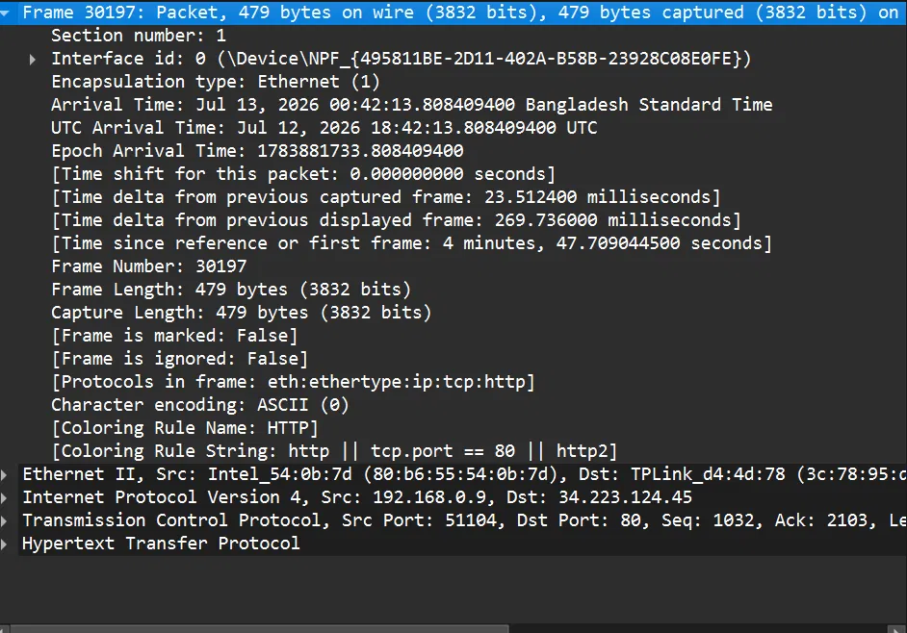

From the information:
The Frame number :30197 is the packet's position in the capture.
The total size of the packet on the wire and capture is 479 bytes(frame length)
The time for receiving this packet is the Arrival Time
The protocol stack for the packet: eth:ethertype:ip:tcp:http

2.Ethernet II layer:
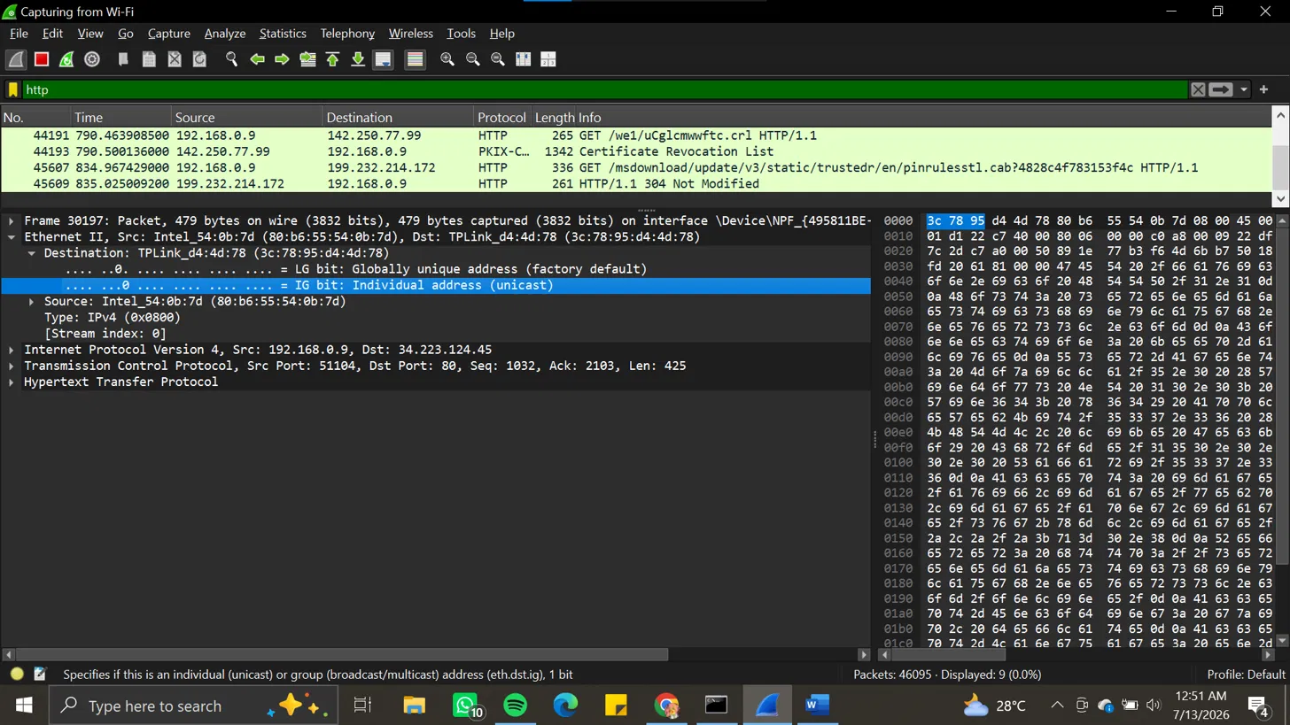

Using the Mac address it handles the delivery of the frame on the local network segment. It rewritten the address on every hop and passed it to the destination server.

3. Internet Protocol Version 4 layer :
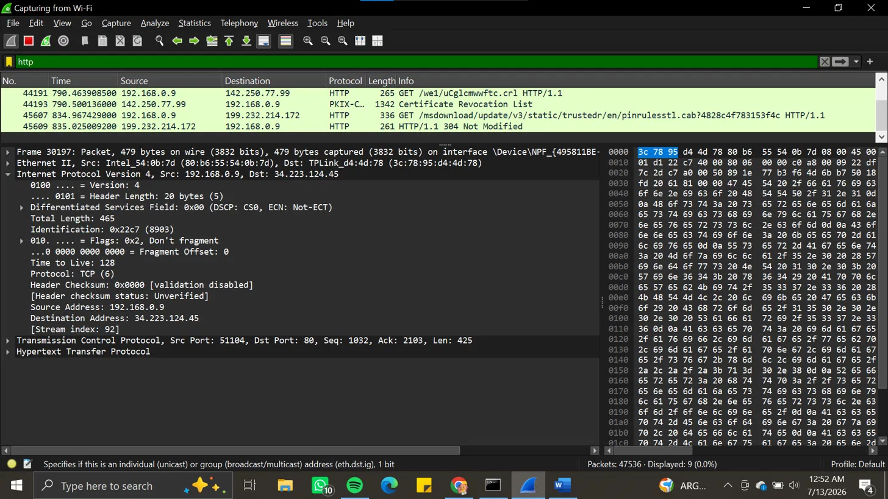
Responsible for IP address, routing and end to end addressing .

The Source address and the destination address are the local IP address of the clients machine and neverssl.com web server.
The length of the IP packet is 456 bytes.
Maximum router hop or TLL is 128 and the TCP protocol was carried in the IP packet.
The instruction for the routers not to fragment the packet is Figs: ox2,Don’t Fragment

4.Transport Layer :
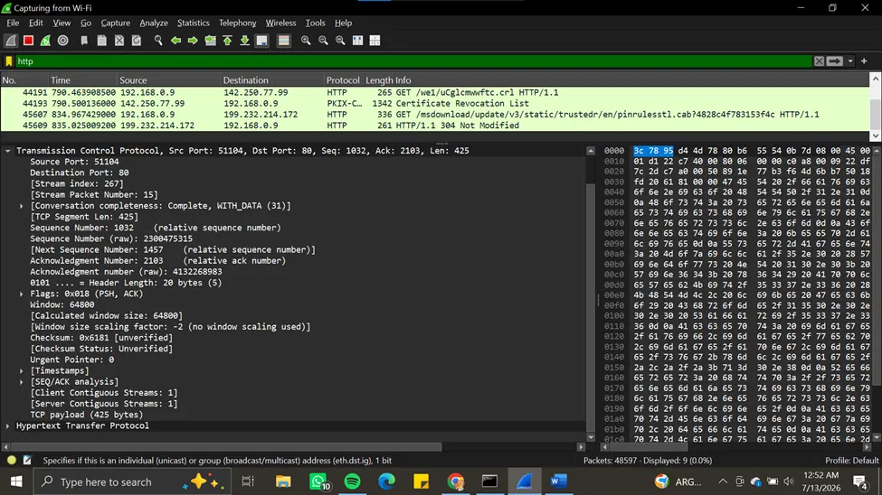
Here the destination port is 51104 is a randomly chosen port and the source port is 80 server matches the destination port and the Flags PSH+ACK here is acknowledging the prior data when the data pushed immediately

5.HTTP Layer:
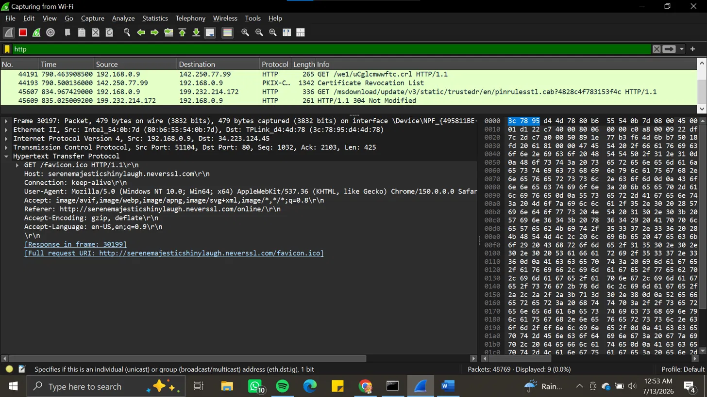
Here the actual GET request is identifying the target domain ,identifying the browser is done by the User agent and the listing of image format will be accepted.

RESPONSE PACKET(30199):
- Frame layer :

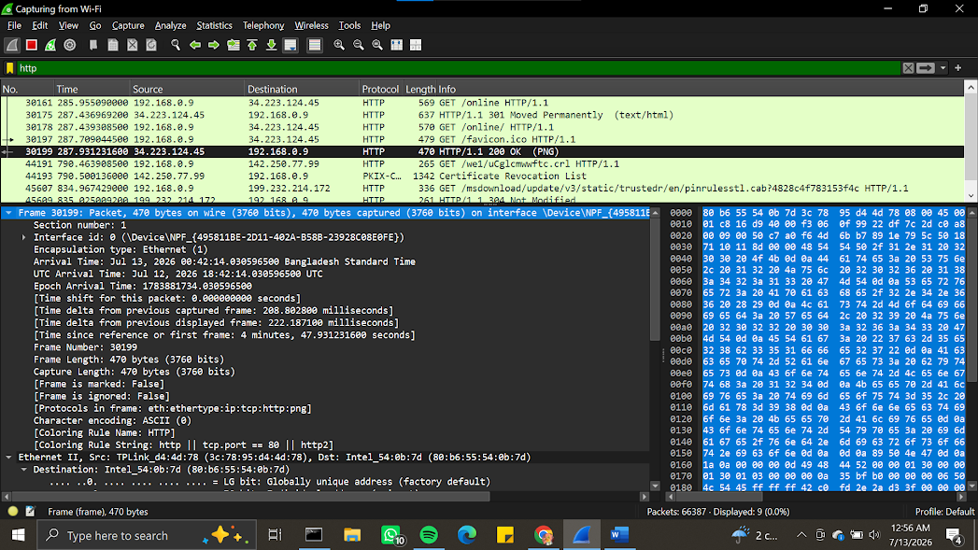

Here the frame number is 30199 arrived 222ms and 470 bytes after the request was done .Here the protocol used eth:lp:tcp:http:png the PNG file and all other network layer .

2.Ethernet II Layer: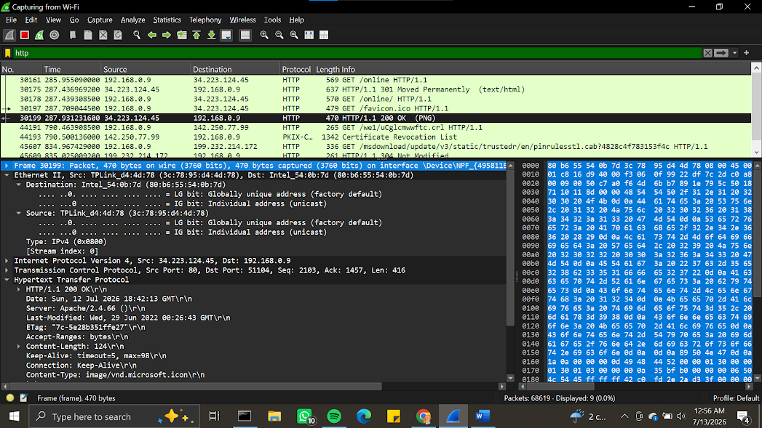

It is showing the MAc addresses for the source router and destination of the client’s adapter .

3.IPv4 Layer : 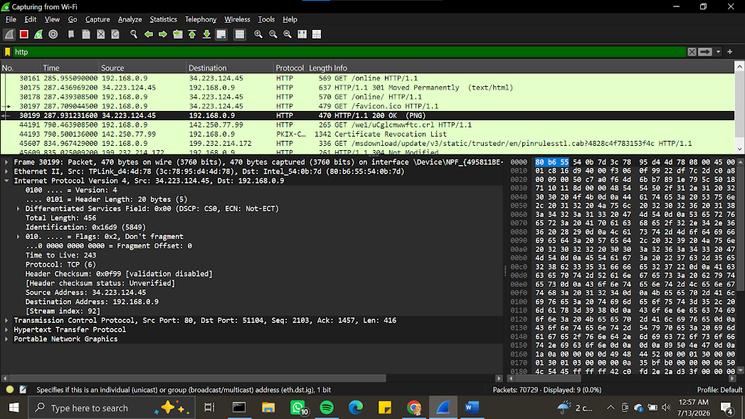

Here the IP addresses are shown the TTL is 243 whereas the TTL of the client was 128 . server: (34.223.124.45) and client (192.168.0.9).

4.TCP Layer: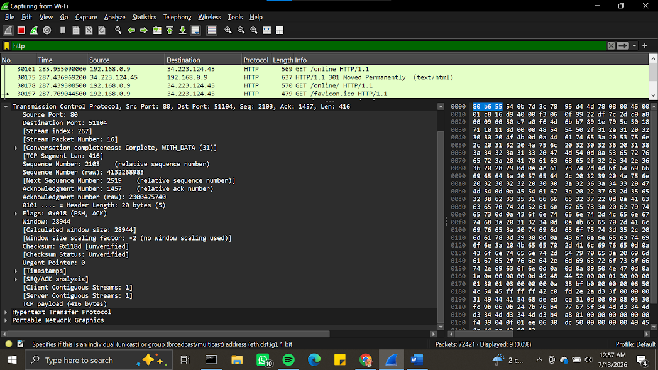

The port 80 confirms the web server's port and the destination port is 51104 which was the client's. Here the command of FLag PSH+ACK is the data pushed immediately acknowledging the previous one’s.
5.HTTP Layer: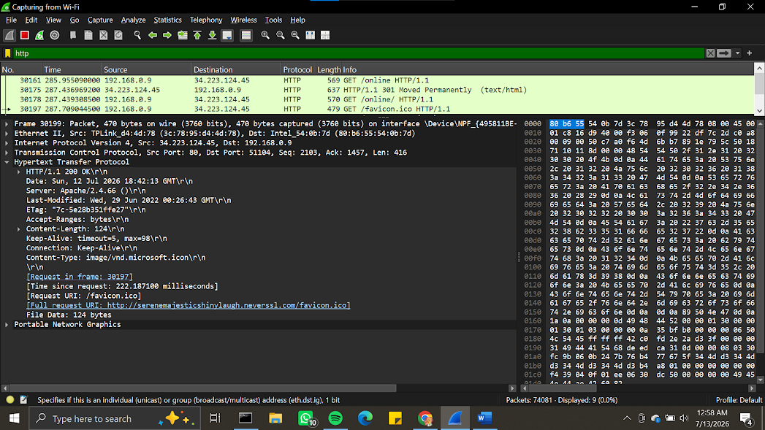
It shows the response as “200 Ok” ,server software and content type . the body of the returned favicon file

